


BEIJING INSTITUTE OF TECHNOLOGY

BIT - MEXICO TOP CHINA 2014
16th June-6th July, 2014
Schedule
Date | Time | Lecture/Activity | Place
15 June  Sun | 15:15-17:30 | Airport Pick-up  Check in International Student Apartment or Hotel, Beijing Institute of Technology | 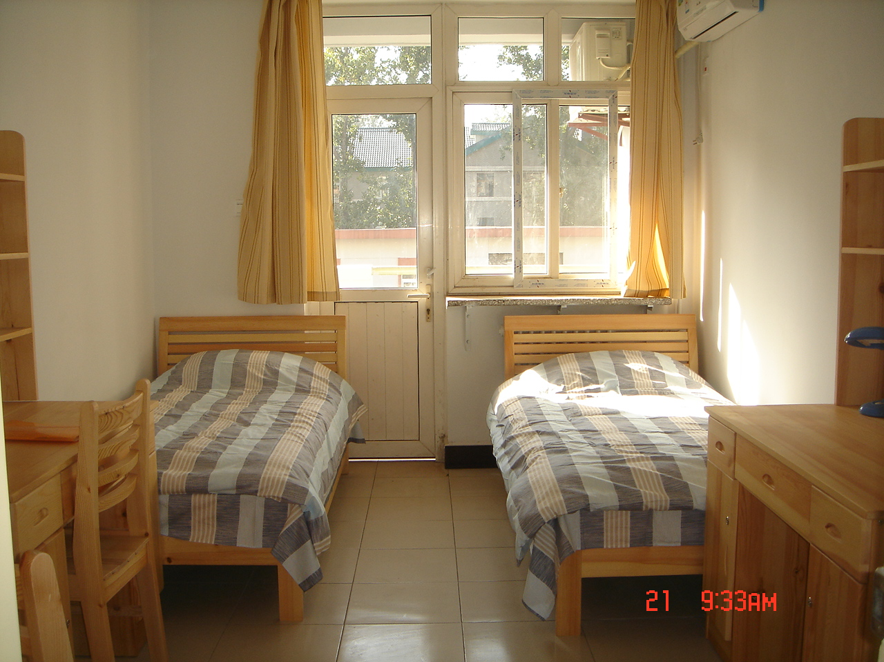
15 June  Sun | 18:00 | Supper | BIT Yanyuan Restaurant
16 June  Mon | 9:30-11:30 | Registration, Orientation,  Meeting with Chinese students from BIT | Graduate Teaching Building  Room 406
16 June  Mon | 12:00-13:30 | Lunch and Rest Time | BIT campus
16 June  Mon | 14:00-16:00 | Campus tour | BIT campus
16 June  Mon | 18:00-20:30 | Fundamental of FPGA Development  By Dr. Qiongzhi Wu & Dr. Zhifeng Ma | Teaching Building No.4 Room 338
17 June  Tue | 08:00-9:50 | Electrical Engineering & its Implementation Fundamentals  By Prof. Dake Liu | Graduate Teaching Building  Room 206
17 June  Tue | 10:00-11:50 | Electrical Engineering & its Implementation Fundamentals | Graduate Teaching Building  Room 206
17 June  Tue | 12:00-15:00 | Lunch and Rest Time | Graduate Teaching Building  Room 206
17 June  Tue | 15:00-17:00 | Opening Ceremony | BIT International Exchange Building
17 June  Tue | 17:40-20:30 | Welcome Dinner | BIT International Exchange Building
18 June  Wed | 08:00-9:50 | Chinese or Spanish Course  Mexico Group A: Ms. Cui  Mexico Group B: Ms. Zhang | Mexico A: Central Teaching Building 430  Mexico B: Central Teaching Building 431  BIT students : Graduate Teaching Building Room 210
18 June  Wed | 10:00-11:50 | Chinese or Spanish Course  Mexico Group A: Ms. Wang  Mexico Group B: Ms. Sun
18 June  Wed | 12:00-13:00 | Lunch and Rest Time
18 June  Wed | 13:30-16:30 | Visit the Summer Palace | 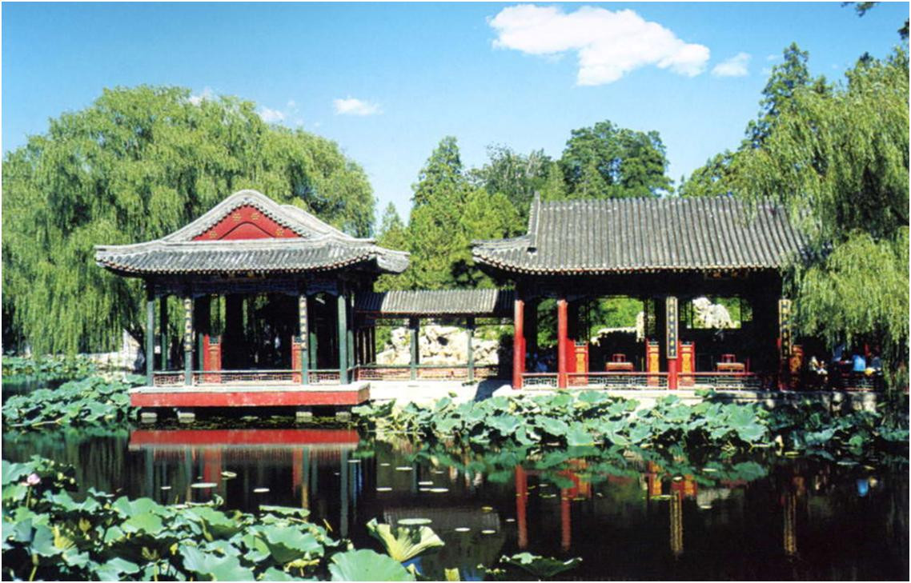
19 June  Thu | 08:00-9:50 | Electrical Engineering & its Implementation Fundamentals | Graduate Teaching Building  Room 206
19 June  Thu | 10:00-11:50 | Electrical Engineering & its Implementation Fundamentals | Graduate Teaching Building  Room 206
19 June  Thu | 12:00-15:00 | Lunch and Rest Time
19 June  Thu | 15:00-16:30 | Fundamental of FPGA Development | Teaching Building No.4 Room 338
20 June  Fri | 9:00-10:20 | Lecture: Energy  By Prof. Francisco Piñon | Graduate Teaching Building  Room 304
20 June  Fri | 10:30-11:50 | Lecture: Chinese history and Culture  by Ms. Lai Xia | Graduate Teaching Building  Room 304
20 June  Fri | Free Time
21 June  Sat | 8:00-12:00 | Visit Qianmen Ancient Cultural Street and Tian'anmen Square | 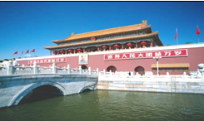
21 June  Sat | 12:00-13:30 | Lunch and Rest Time
21 June  Sat | 14:00-17:00 | Visit the Forbidden City
22 June  Sun | 8:00-17:00 | Visit the Great Wall, etc. | 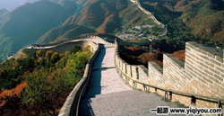
23 June  Mon | 9:00-10:20 | Lecture: Statistics  By Prof. Fabiola Lima | Graduate Teaching Building  Room 304
23 June  Mon | 10:30-11:50 | Chinese society and economy  by Ms. Liu Wei | Graduate Teaching Building  Room 304
23 June  Mon | 12:00-13:30 | Lunch and Rest Time
23 June  Mon | 13:30-15:00 | Fundamental of FPGA Development | Teaching Building No.4 Room 338
23 June  Mon | 15:15-16:45 | Study Chinese Long boxing  By Mr. Wei Zuan | 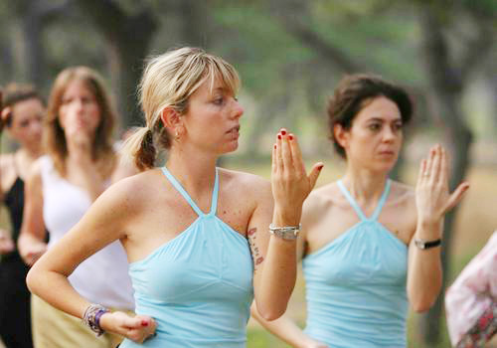
24 June  Tue | 8:00-9:50 | Fundamental of FPGA Development | Teaching Building No.4 Room 338
24 June  Tue | 10:00-11:50 | Fundamental of FPGA Development | Teaching Building No.4 Room 338
24 June  Tue | 12:00-13:30 | Lunch and Rest Time
24 June  Tue | 13:30-16:30 | Visit Beijing Urban Planning Exhibition Hall | 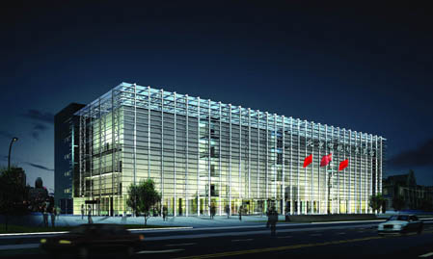
25 June  Wed | 08:00-9:50 | Chinese or Spanish Course | Mexico A: Central Teaching Building 430  Mexico B: Central Teaching Building 431  BIT students : Graduate Teaching Building Room 210
25 June  Wed | 10:00-11:50 | Chinese or Spanish Course
25 June  Wed | 12:00-13:30 | Lunch and Rest Time | 
25 June  Wed | 13:30-15:00 | Visit the Chinese National Museum
25 June  Wed | 18:00-21:30 | Chinese Acrobatics show
26 June  Thu | 8:00-9:50 | Fundamental of FPGA Development | Teaching Building No.4 Room 338
26 June  Thu | 10:00-11:50 | Fundamental of FPGA Development | Teaching Building No.4 Room 338
26 June  Thu | 12:00-13:30 | Lunch and Rest Time
26 June  Thu | 13:30-15:00 | Orientation for Shanghai Trip | Student Apartment No.14 Room 111
27 June  Fri | 9:00-10:20 | Lecture: Dynamics  By Prof. Salvador Baltazar | Graduate Teaching Building  Room 304
27 June  Fri | 10:30-11:50 | Lecture: Travel in China  Mr. Qiu Bingjun | Graduate Teaching Building  Room 304
27 June  Fri | 17:00 | Leaving for Shanghai by train
28 June  Sat | 8:00-12:00 | Visit the Bund, the City God Temple, Yuyuan Garden etc. | 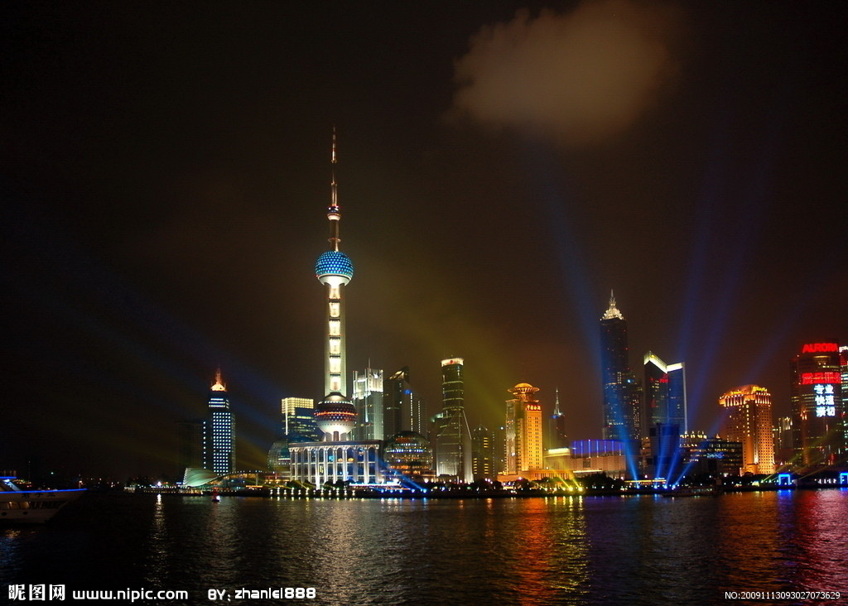
28 June  Sat | 13:00-16:30 | Visit the Nanjing Street
28 June  Sat | 18:00-21:30 | Night cruise on Huangpu River
29 June  Sun | 8:00-11:50 | Visit Shanghai Museum, Pudong New Area | 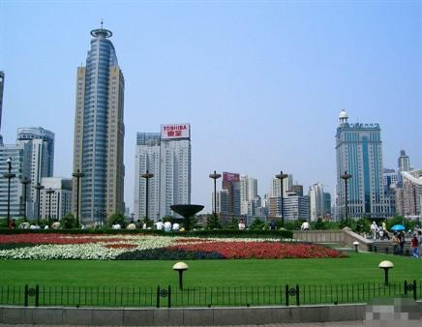
29 June  Sun | 13:30-16:00 | Shopping time
29 June  Sun | 17:00-22:00 | Returning to Beijing
30 June  Mon | 8:00-11:50 | Lecture: Chinese calligraphy & painting  by Ms. Zhang Hong | Student Apartment No.14 Room 111
30 June  Mon | 12:00-13:30 | Lunch and Rest Time | Student Apartment No.14 Room 111
30 June  Mon | 13:30-15:00 | Fundamental of FPGA Development | Teaching Building No.4 Room 338
30 June  Mon | 15:15-16:45 | Study Chinese Long boxing  By Mr. Wei Zuan | 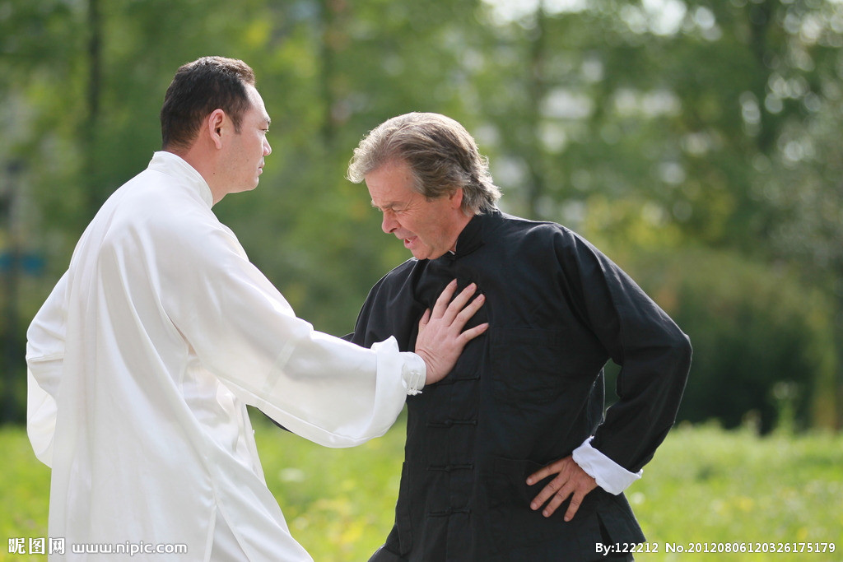
1 July  Tue | 8:00-9:50 | Chinese and Spanish Course | Mexico A: Central Teaching Building 430  Mexico B: Central Teaching Building 431  BIT students : Graduate Teaching Building Room 210
1 July  Tue | 10:00-11:50 | Chinese and Spanish Course
1 July  Tue | 12:00-13:30 | Lunch and Rest Time | 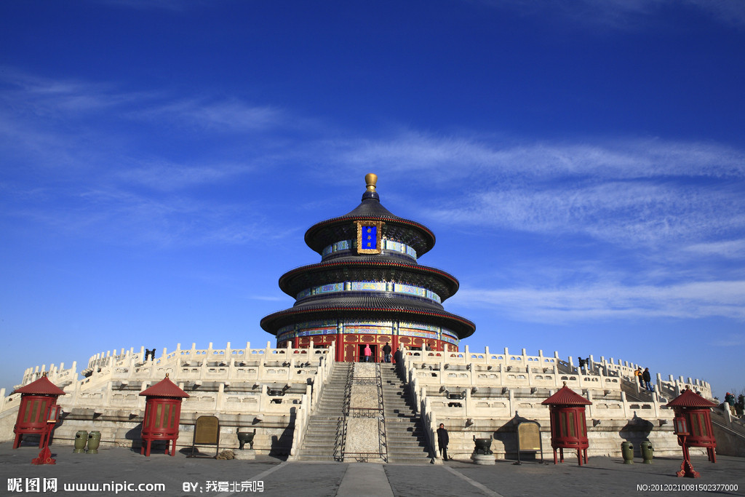
1 July  Tue | 13:30-16:30 | Visit the Temple of Heaven and Hongqiao Market
1 July  Tue | 19:00-21:30 | Peking Opera Show
2 July  Wed | 8:00-9:50 | Fundamental of FPGA Development | Teaching Building No.4 Room 338
2 July  Wed | 10:00-11:50 | Fundamental of FPGA Development | Teaching Building No.4 Room 338
2 July  Wed | 12:00-13:30 | Lunch and Rest Time
2 July  Wed | 13:30-15:00 | Fundamental of FPGA Development | Teaching Building No.4 Room 338
2 July  Wed | 16:30-17:30 | Preparing for Final Exam | Apartment 14# Room 107
3 July  Thu | 8:00-11:50 | Chinese paper-Cut, calligraphy & painting | Student Apartment No.14 Room 111
3 July  Thu | 12:00-13:30 | Lunch and Rest Time | 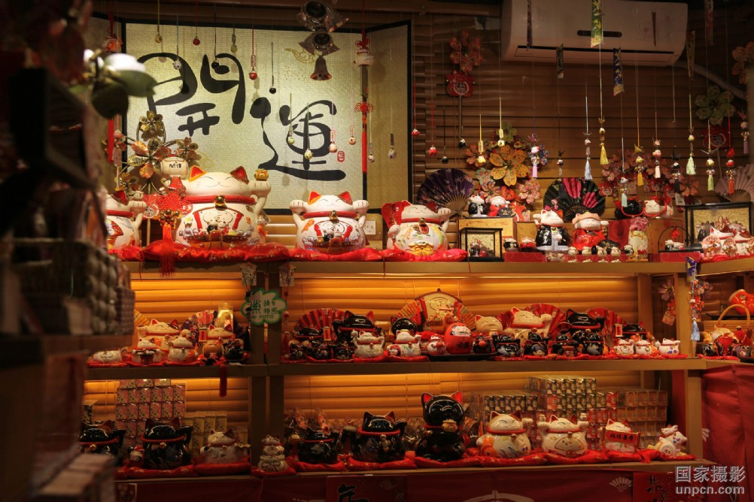
3 July  Thu | 13:30-16:00 | Visit Beijing Hutong:  South Luogu Alley
3 July  Thu | 18:00-20:00 | Preparing for Final Exam | Apartment 14# Room 107
4 July  Fri | 8:00-11:50 | Final Exam | Teaching Building No.4 Room 338
4 July  Fri | 12:00-15:00 | Lunch and Rest Time
4 July  Fri | 15:00-17:30 | Closing Ceremony and  Farewell Dinner | BIT International Exchange Building
5 July  Sat | Visit the National Stadium and Water Cube |  | 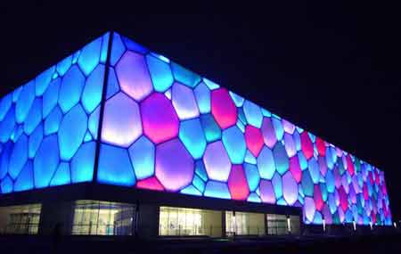
6 July  Sun | Check-out and see off |  | 

